H.T No
Regulations:
A15

Sreenidhi Institute of Science and Technology
(An Autonomous Institution)
Code No: 5AC41 Date: 10-Oct-2020 (FN)

B.Tech II-Year I-Semester External Examination, October - 2020 (Supplementary)
Elements of Electrical Engineering (CSE and IT)

Time: 2 Hours Max.Marks:75

Note: a) No additional answer sheets will be provided.
b) All sub-parts of a question must be answered at one place only, otherwise it will not be valued.
c) Missing data can be assumed suitably.

ANSWER ANY 5 OUT OF 8 QUESTIONS. EACH QUESTION CARRIES 15 MARKS.

1. | a) | Determine the number of nodes and branches for circuit shown in below figure and also find the current in each branch. 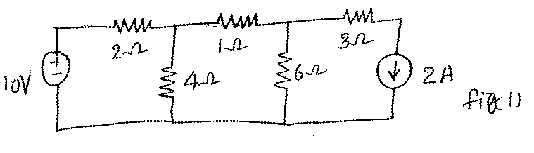 | [8M]
 | b) | Find the equivalent resistance between the terminals AB in the below figure.  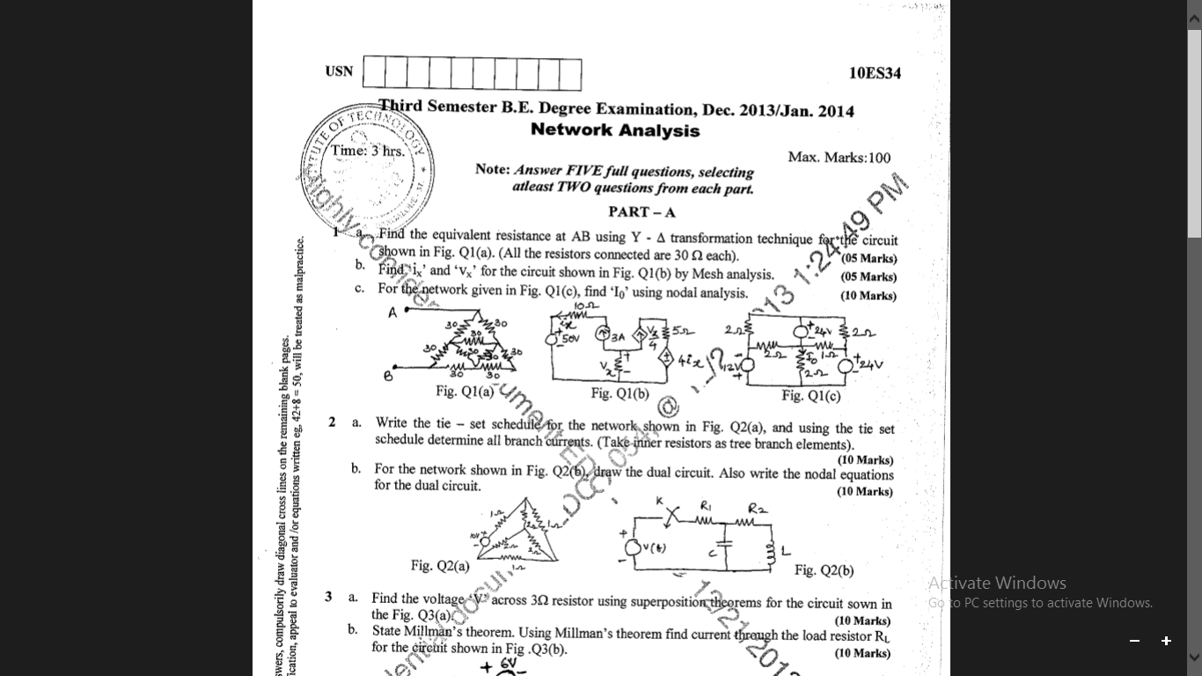 | [7M]
2. | a) | For the network of Fig. write directly the mesh current equation in matrix notation and hence determine I₁ and I₂  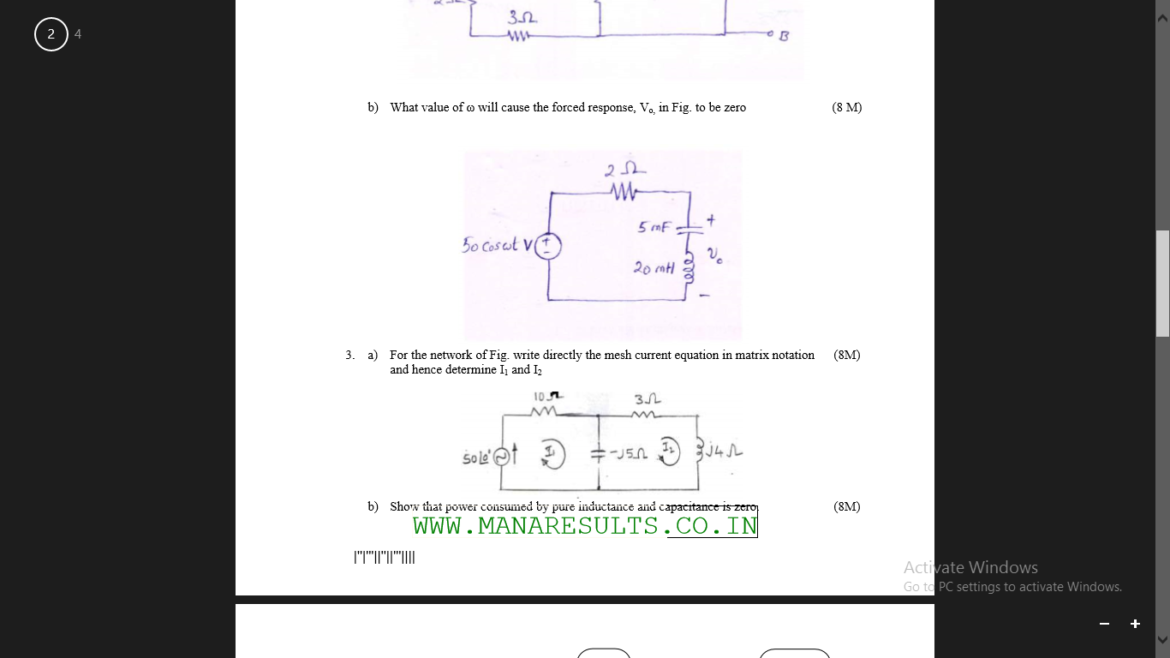 | [8M]
 | b) | Find the Root Mean Square value, Average value, Form Factor, Peak factor for the wave form shown below.  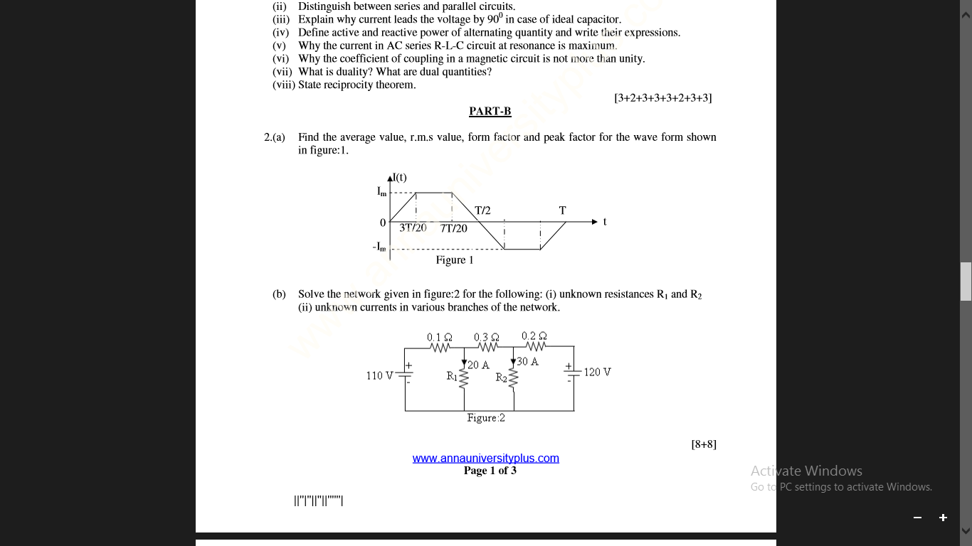 | [7M]
3. | a) | Derive the EMF equation of DC generators. | [8M]
 | b) | A 500V DC Shunt Motor running at 700rpm takes an armature current of 50A.Its effective armature resistance is 0.4Ω. What resistance must be placed in series with the armature to reduce the speed to 600rpm, the torque remaining constant. | [7M]
4. |  | A single phase, 4KVA, 200/400 V, T/F, gave the following test result.  O.C test 200V 0.7A 60W (L.V. Side)  S.C test 9V 10A 275W (H.V Side)  (i).Draw equivalent diagram referred to L.V (ii).Find the secondary terminal voltage at 0.8 P.F full loads.(iii).Calculate the voltage regulation and efficiency at 65% load with 0.8 p.f. lagging. | [15M]
5. | a) | Explain how the rotating magnetic field is produced in the three phase induction Motor? | [8M]
 | b) | A three phase, 4-pole, 50Hz induction motor supplies a useful torque of 159N-M. Calculate at %slip  (i) The rotor input (ii) The motor input  (iii) The motor efficiency  if fraction and Windage loss is 500W and the stator losses equal to 1000W | [7M]
6. |  | Explain about construction features and working of Permanent magnet moving coil (PMMC) voltmeter with neat diagram? | [15M]
7. | a) | State and explain Norton's theorem with example. | [8M]
 | b) | A separately excited generator when running at 1000rpm supplied 200A at 125V. What will be the load current when the speed drops to 800rpm if If is unchanged? Given that armature resistance=0.04Ω and brush drop=2V. Derive the necessary equations. | [7M]
8. | a) | Explain the constructional details and working principle of three phase induction motor with neat sketch? | [8M]
 | b) | A11000/230 V, 150 KVA, 1-phase, 50Hz transformer has core loss of 1.4kW and F.L cu loss of 1.6KW. Determine  (i) The KVA load for maximum efficiency and the value of maximum efficiency at unity p.f  (ii) The efficiency at half F.L 0.8 pf leading. | [7M]

-- 00 -- 00 –

